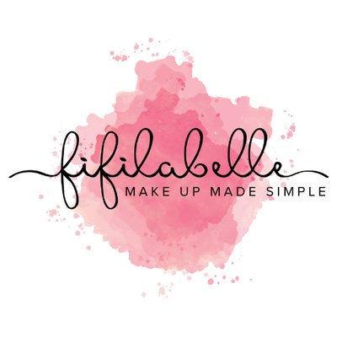

Terms and Conditions
1. Definitions
The Client: The recipient of the service.
Makeup Artist: fifilabelle – MakeUp Made Simple (Fiona MacKenzie)
The Agreement: The contract that exists between the client and fifilabelle – MakeUp Made Simple for the agreed fee.
The fee: The amount payable by the client to the makeup artist for the agreed services
The event: Relates in principal to the date whereby the event takes place.
The party: Additional persons requiring makeup on the day.
2. Payment: Payment can be made in cash, by card or via bank transfer. Cheques will not be accepted.
3. Responsibility of the client: The client shall inform the makeup artist of any issues that may affect the use of any equipment or products. This includes but is not limited to sensitivities, allergies and medical conditions. The makeup artist cannot be held liable for any losses that are incurred due to the client’s failure to inform them of any known condition. The makeup artist reserves the right to refuse service to the client or members of the party for, but not limited to, abusive and threatening behaviour.
4. Cancellations: Booked services must be cancelled in writing (email) no later than 24 hours before the event.
5. Gift Vouchers: All Gift Vouchers are dated and expire 12 months from the date of issue. Gift Vouchers cannot be exchanged for cash. Gift Vouchers are non-refundable.
6. Photography: Photographic/video images of the client, members of the booking or event may be used by the artist on social media unless the client has expressly withdrawn their consent in writing.

7. Travel Expenses: The cost of the artist’s travel is covered by the client. Travel is charged at 40p a mile after 10 miles from the artist’s postcode and the same for the return journey. If the artist is travelling by public transport the artist will give you a quote for this. Parking costs are chargeable to the client.

